FOOD MANAGEMENT SYSTEM

Use-Case Specification: Deleting Product

Version <1.0>

Revision History

|  |  |  |  |
| --- | --- | --- | --- |
| **Date** | **Version** | **Description** | **Author** |
| <7/12/2020> | <1.0> | <details> | <Nguyen Thu Trang> |

Table of Contents

1. Use-Case Name 4

1.1 Brief Description 4

2. Flow of Events 4

2.1 Basic flow 4

2.2 Alternative flow 4

2.2.1 <First Alternative flow> 4

2.2.1 <Second Alternative flow> 4

3. Special Requirement 4

3.1 <First Special Requirement> 4

4. Preconditions 5

4.1 <Precondition One> 5

5. Posstcondition 5

5.1 <Postcondition One> 5

6. Extension Points 5

6.1 < Name of Extension Points> 5

Use-Case Specification: Deleting Product

1. **Remove product**
   1. **Brief Description**

This use case defines the step of removing computers. The system allow admin to  remove information involved to product.

* 1. **Actor**

Admin

1. **Flow of Events**
   1. **Basic Flow**

First, admin click on Delete product button on product detail. The system display product view. Admin will input information of product (id, name, price, etc) need to be deleted. Admin click on Save button to confirm.

Admin click on update button to confirm change. System will update product information, show notification on screen and save it in database.

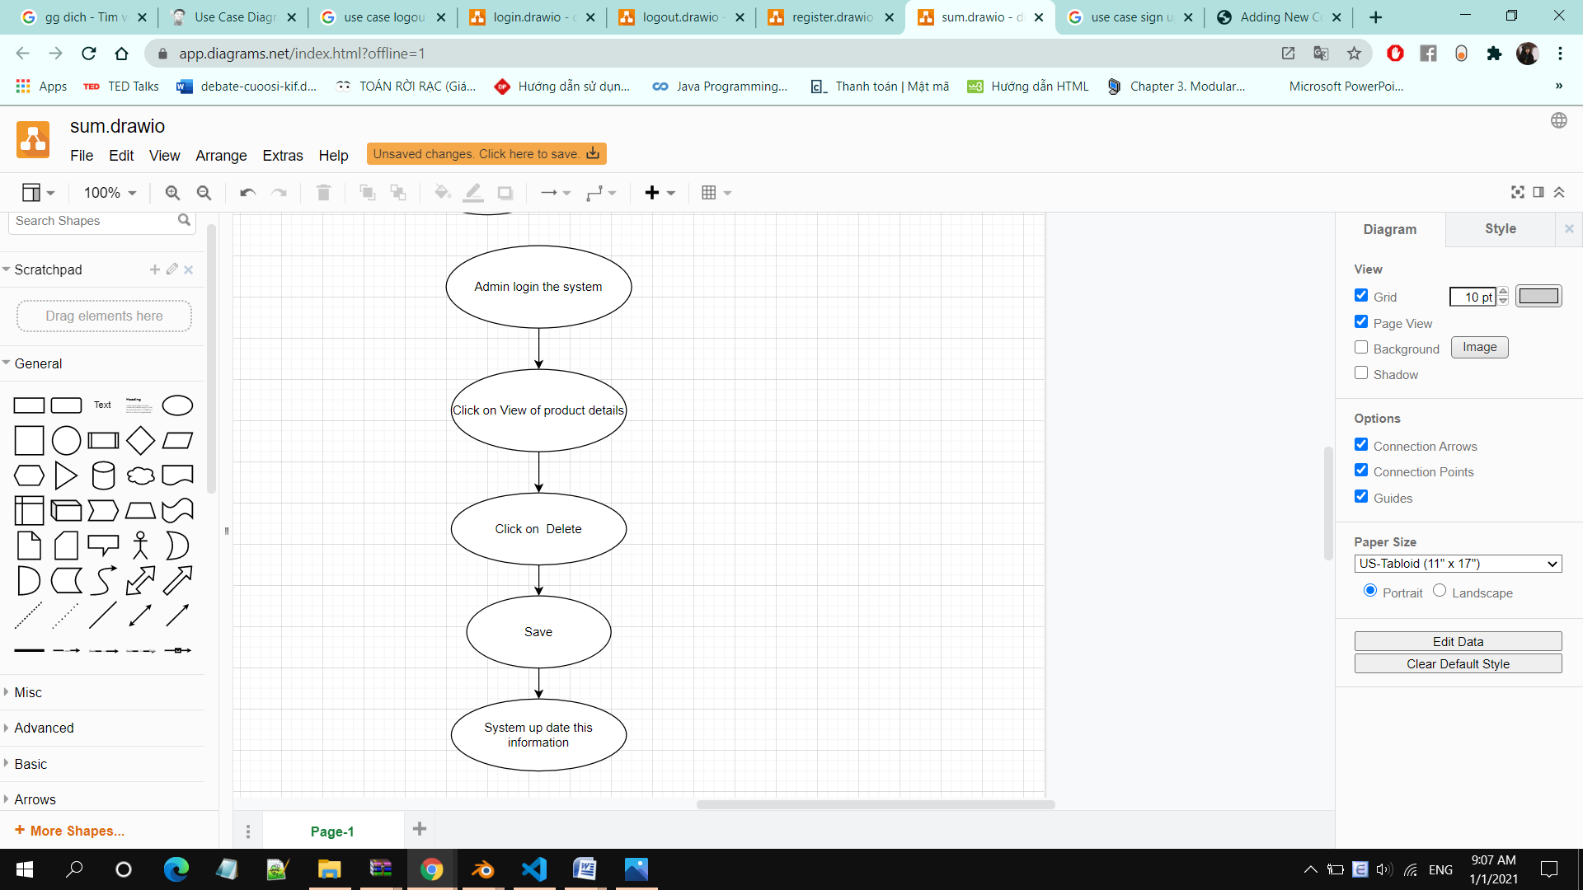

1. **Special Requirements**

Admin must know how to use the product management system.

1. **Preconditions**

Admin must chose the reason why remove the product

1. **Postconditions**

The removed product must be removed from database

1. **Extension Points**

No extension points.